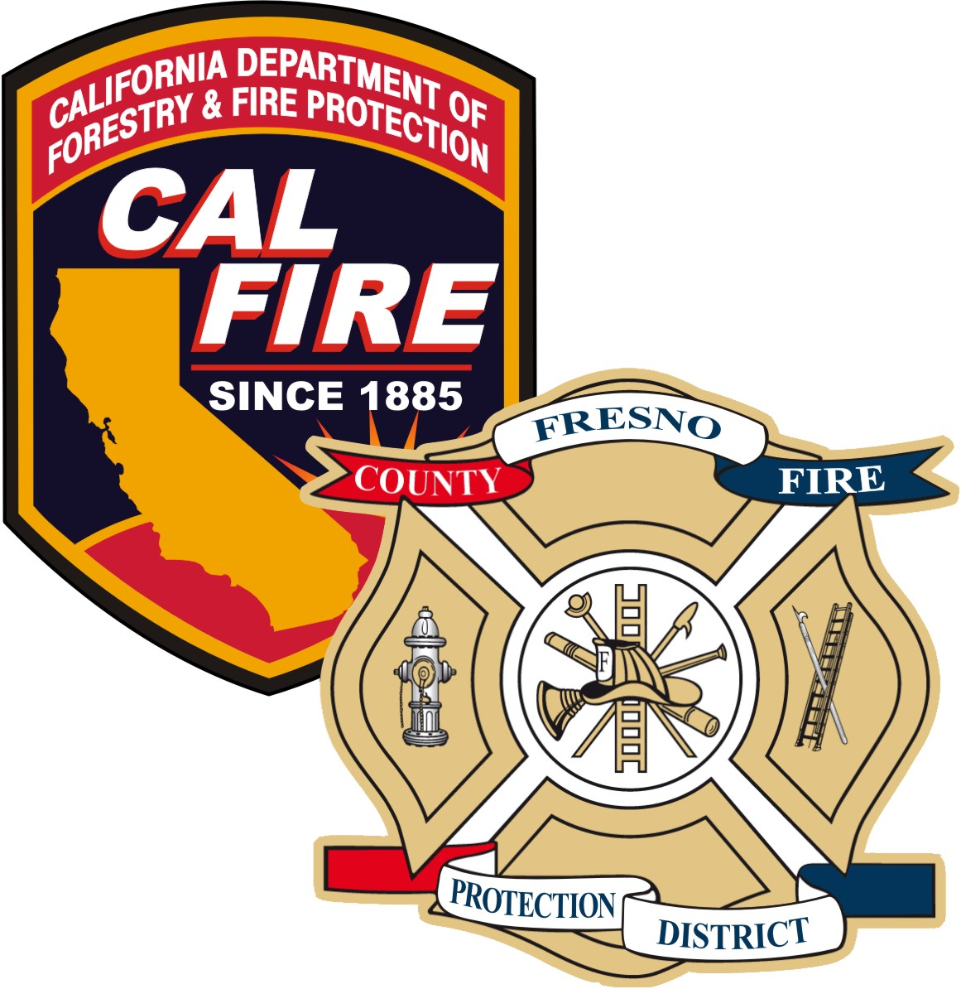
FRESNO COUNTY FIRE
PROTECTION DISTRICT 1700 Jensen Ste 103
Sanger, California 93657
Telephone: (559)319-0400
Fax: (559)272-2410
www.fresnocountyfire.org

WATER FLOW REQUEST

This form is to be used by fire sprinkler contractors to request the water flow for the project location specified. Complete Section 1 and send to Fresno County Fire Protection District. This form, with both Sections 1 and 2 completed, must be submitted to Fresno County Fire Protection District with the fire sprinkler plans.
SECTION 1
REPORT DATE: | COMPANY REQUESTING FLOW INFORMATION:
COMPANY ADDRESS: |  |  | CITY: | STATE:
COMPANY PHONE NUMBER:  - |  | FAX NUMBER:  ( ) -
CONTACT PERSON: |  |  | EMAIL: (Contact Person)
PROJECT NAME: |  |  | PROJECT LOCATION:
STREET WHERE WATER SERVICE WILL BE OBTAINED FROM:

Do not write below this line – To be completed by Fresno County Fire Protection District
SECTION 2
LOCATION OF TESTED HYDRANT:

DATE HYDRANT FLOWED: | TIME HYDRANT FLOWED: |  | HYDRANT NUMBER or ID:
STATIC:  ________ PSI | RESIDUAL:  PSI |  | PITOT:  PSI
FLOW:  GPM | COMMENTS:
INFORMATION SENT BY: ◻ Fax ◻ Phone ◻ Mail ◻ E-Mail By: Larry E Brown Date:_______

